**Online Appendix for Andy Baker, “Race, Paternalism, and Foreign Aid: Evidence from U.S. Public Opinion” *American Political Science Review***

1. DESIGN OF TWO EXPERIMENTS

1. CM experiment

|  |  |  |  |  |  |
| --- | --- | --- | --- | --- | --- |
| Beginning of opening text (shown to all respondents): “Foreign aid is money that the U.S. government sends to poor countries to help them fight poverty. A lot of the aid money that we send overseas goes to poor African/East European countries like Cameroon/Moldova, where the average person survives on the US equivalent of $5 per day. (That would be like living on $1,800 per year in the US.)” | | | | | |
|  |  | **Paternalistic Form** | | | |
|  |  | Unspecified | Coercive (+ Valence) | | Coercive (˗ Valence) |
| **Race** | Cameroon | End of opening text: “The aid money is often used by poor Cameroonian families like the one pictured above.” | End of opening text: “The aid money is often used by poor Cameroonian families like the one pictured above. An American aid expert (like the one pictured above) is often on hand to tell the poor how to use the aid to improve their lives.” | | End of opening text: “The aid money is often used by poor Cameroonian families like the one pictured above. An American aid expert (like the one pictured above) is often on hand to instruct but sometimes limits the choices that the poor recipients of aid can make.” |
| Moldova | End of opening text: “The aid money is often used by poor Moldovan families like the one pictured above.” | End of opening text: “The aid money is often used by poor Moldovan families like the one pictured above. An American aid expert (like the one pictured above) is often on hand to tell the poor how to use the aid to improve their lives.” | | End of opening text: “The aid money is often used by poor Moldovan families like the one pictured above. An American aid expert (like the one pictured above) is often on hand to instruct but sometimes limits the choices that the poor recipients of aid can make.” |
|  |  |  |  | |  |
|  |  | Control group |  |  | |
|  |  | End of opening text: “The aid money is often used by poor families.” [No photo] |  |

2. AG Experiment

|  |  |  |  |  |  |
| --- | --- | --- | --- | --- | --- |
| Beginning of opening text (shown to all respondents): “Foreign aid is money that the U.S. government sends to poor countries to help them fight poverty. A lot of the aid money that we send overseas goes to poor Caribbean/East European countries like Guyana/Armenia, where the average person survives on the US equivalent of about $7 per day. (That would be like living on $2,500 per year in the US.)” | | | | | |
|  | |  | **Paternalistic Form** | |
|  | |  | Unconditional Cash | In-kind |
| **Race** | Armenia | End of opening text: “The aid money is often used by poor Armenian families like the one pictured above. The families often receive the aid as cash so that they can spend it any way they would like.”  Description: white_2012_20dpi.jpg | End of opening text: “The aid money is often used by poor Armenian families like the one pictured above. The families often receive the aid as particular goods and services, such as free school materials or free doctors’ visits.”  Description: white_2012_20dpi.jpg |
| Guyana | End of opening text: “The aid money is often used by poor Guyanese families like the one pictured above. The families often receive the aid as cash so that they can spend it any way they would like.”  Description: black_2012_20dpi.jpg | End of opening text: “The aid money is often used by poor Guyanese families like the one pictured above. The families often receive the aid as particular goods and services, such as free school materials or free doctors’ visits.”  Description: black_2012_20dpi.jpg |

1. SAMPLING AND RESPONSE RATES

Knowledge Networks (KN) uses probability-based sampling that selects thousands of potential respondents, called panel members, via random digit dialing and addressed-based sampling. KN invited 3,031 of its panel members (chosen randomly) to participate in the survey, and 2,031 did so for a response rate of 67%. All analyses are conducted with survey weights that were provided by KN to correct for a variety of deviations from random selection into the final sample, including panel attrition, non-response, and oversampling of minorities.

The CCES, which is carried out by YouGov/Polimetrix, uses a sample matching technique to secure a set of 1,000 respondents (drawn from its larger pool of potential respondents that have opted in to fill out its periodic on-line surveys) that approximates national representativeness. In essence, the technique first creates a hypothetical sample of 1,000 persons that looks (on several demographic dimensions) like an ideal simple random sample, and then it finds an actual respondent from the opt-in panel that closely matches each “individual” in the hypothetical sample. Weights are provided (and used in all analyses in this paper) to correct for the fact that perfect matches for all 1,000 hypothetical individuals are never available. See Ansolabehere and Rivers (2013) for more information.

1. RANDOMIZATION CHECK

There is increasing recognition that randomization checks are unnecessary in experimental research, since the only assumption needed to ensure unbiased treatment effect estimates is that the different experimental groups are drawn from the same *underlying* population (Mutz 2011, 109-112). Moreover, hypothesis tests of treatment effects on the dependent variable include (in the null) the possibility that randomization produced an unlikely result. Mutz goes so far as to say that randomization checks are “irrelevant to the internal validity of experimental results” (2011, 112). Nonetheless, I report checks here since randomization could be flawed by procedural or software errors. I look at whether the different experimental groups have statistically indistinguishable means on three pretreatment variables that are known correlates of foreign aid attitudes: ideology, partisanship, and education. The table shows estimated means and 95% confidence intervals. In the CM experiment, all of the means are statistically indistinguishable from one another. In the AG experiment, just one mean (that on education in the Armenia × In-kind treatment group) appears to deviate from the others. Given that, by sheer chance, one is bound to find occasional deviant means like this, I interpret these findings as evidence that the mechanics of randomization worked properly for both experiments.

|  |  |  |  |
| --- | --- | --- | --- |
| **Randomization Check: Mean and 95% Confidence Intervals on Three Pretreatment Variables by Experimental Conditions** | | | |
| Experimental Condition (CM) | Ideology | Partisanship | Education |
| Control | 4.45  [4.28, 4.62] | 4.32  [4.08, 4.56] | 10.46  [10.27, 10.65] |
| Moldova × Unspecified | 4.36  [4.18, 4.53] | 4.18  [3.93, 4.42] | 10.48  [10.28 10.68] |
| Cameroon × Unspecified | 4.43  [4.26, 4.60] | 4.35  [4.11, 4.58] | 10.42  [10.22, 10.62] |
| Moldova × Coercive Paternalism (+) | 4.38  [4.21, 4.55] | 4.14  [3.89, 4.39] | 10.33  [10.12, 10.54] |
| Cameroon × Coercive Paternalism (+) | 4.39  [4.22, 4.56] | 4.18  [3.94, 4.23] | 10.46  [10.23, 10.68] |
| Moldova × Coercive Paternalism (-) | 4.42  [4.24, 4.60] | 4.34  [4.09, 4.59] | 10.39  [10.16, 10.62] |
| Cameroon × Coercive Paternalism (-) | 4.39  [4.22, 4.56] | 4.26  [4.02, 4.50] | 10.46  [10.25, 10.67] |
|  |  |  |  |
| Experimental Condition (AG) |  |  |  |
| Armenia × Unconditional Cash | 4.36  [4.13, 4.59] | 3.71  [3.43, 3.99] | 3.68  [3.50, 3.86] |
| Guyana × Unconditional Cash | 4.29  [4.05, 4.53] | 3.79  [3.50, 4.08] | 3.56  [3.37, 3.75] |
| Armenia × In-kind | 4.32  [4.10, 4.54] | 3.74  [3.46, 4.02] | 3.43  [3.25, 3.61] |
| Guyana × In-kind | 4.19  [3.96, 4.42] | 3.64  [3.36, 3.92] | 3.80  [3.61, 3.99] |

1. QUESTION WORDINGS
2. Items in the *Index of support for foreign aid*

*Preferred aid amount per American*

Overall, each year the US government gives about $40 of each American’s income to foreign countries. Many people think this is too low, others think it is too high, and still others think it is about right. How much per American do you think our government should spend on foreign aid?

0 $0. The U.S. should not give any foreign aid.

10 $1 to $19. The U.S. should lower the amount by a lot.

29.5 $20 to $39. The U.S. should lower the amount by a little.

40 $40. The current amount is about right.

50 $41 to $59. The U.S. should raise the amount by a little.

69.5 $60 to $79. The U.S. should raise the amount by a lot.

90 $80 or more. The U.S. should raise the amount by a huge sum.

*Preferred aid amount in the exemplary country* (CM)

Now we'd like to ask your opinion about foreign aid in a slightly different way. What about aid to Cameroon,/Moldova,/poor countries where the average person survives on the US equivalent of about $1,800 per year, of which about $50 comes from wealthy foreign countries as aid. Do you think that U.S. spending on foreign aid to Cameroon/Moldova/poor countries should increase, decrease or be kept about the same? If you think it should increase or decrease, please specify by how much.

1. It should decrease to zero.
2. It should decrease a lot.
3. It should decrease a little.
4. It should stay the same.
5. It should increase a little.
6. It should increase a lot.
7. It should increase by a huge sum.

*Preferred aid amount in the exemplary country* (AG)

Now we'd like to ask your opinion about foreign aid in a slightly different way. What about aid to Guyana,/Armenia, where the average person survives on the US equivalent of about $2,500 per year, of which about 3% comes from wealthy foreign countries as aid. Do you think that U.S. spending on foreign aid to Guyana/Armenia should increase, decrease or be kept about the same? If you think it should increase or decrease, please specify by how much.

1. It should decrease to zero.
2. It should decrease a lot.
3. It should decrease a little.
4. It should stay the same.
5. It should increase a little.
6. It should increase a lot.
7. It should increase by a huge sum.

*US has moral obligation to aid* (CM)

Keeping in mind the poor countries of Africa/ Keeping in mind the poor countries of Eastern Europe/ Keeping poor countries in mind, read each of the following statements and then decide how much you agree or disagree with each one:

1. Agree strongly
2. Agree somewhat
3. Neither agree nor disagree
4. Disagree somewhat
5. Disagree strongly

*US has moral obligation to aid* (AG)

Keeping in mind the poor countries of the Caribbean / Eastern Europe, please answer the following questions. 1 means you agree completely with the statement on the top; 5 means you agree completely with the statement on the bottom; and if your views fall somewhere in between, you can choose any number in between.

1. The US has a moral obligation to financially assist foreign poor countries.
2. The US does NOT have a moral obligation to financially assist foreign poor countries.
3. Items in the *Perception of foreign poor’s agency index*

*Perception of foreign poor’s agency 1* (CM)

Because of difficult economic circumstances, people in poor countries are unable to help themselves get richer.

1. Agree strongly
2. Agree somewhat
3. Neither agree nor disagree
4. Disagree somewhat
5. Disagree strongly

*Perception of foreign poor’s agency 2* (CM)

There is little that people in poor countries can do by themselves to improve their livelihoods.

1. Agree strongly
2. Agree somewhat
3. Neither agree nor disagree
4. Disagree somewhat
5. Disagree strongly

*Perception of foreign poor’s agency 3* (CM)

The only way poor countries could grow richer is with financial help from rich countries.

1. Agree strongly
2. Agree somewhat
3. Neither agree nor disagree
4. Disagree somewhat
5. Disagree strongly

*Perception of foreign poor’s agency 1* (AG)

1. Because of difficult economic circumstances, people in poor countries are unable to help themselves get richer.
2. People in poor countries are able to do things that can help themselves get richer.

*Perception of foreign poor’s agency 2* (AG)

1. There is a lot that poor countries and their citizens can do by themselves to improve their own livelihoods.
2. There is little that poor countries and their citizens can do by themselves to improve their own livelihoods.

*Perception of foreign poor’s agency 3* (AG)

When it comes to improving their economic standard of living, people in poor countries are like extremely sick or paralyzed patients; they are completely unable to help themselves.

1. Agree strongly
2. Agree somewhat
3. Neither agree nor disagree
4. Disagree somewhat
5. Disagree strongly
6. Items in the *Perceived living standards index*

We'd like to get your view on what quality of life is like in poor countries. In [Cameroon,/Moldova,/Guyana,/Armenia/a poor country] where the average person survives on the US equivalent of $1,800 per year ($5 per day)/$2,500 per year ($7 per day), about what percent of households have the following?

a. At least two meals per day.

b. Indoor plumbing.

0 0%

10 10%

20 20%

30 30%

40 40%

50 50%

60 60%

70 70%

80 80%

90 90%

100 100%

1. Items in the *Resentment of the foreign poor index*

*Resentment of foreign poor 1* (CM)

It's really a matter of some people not trying hard enough. If people in poor countries would only try harder, they could be just as well off as the United States.

1. Agree strongly
2. Agree somewhat
3. Neither agree nor disagree
4. Disagree somewhat
5. Disagree strongly

*Resentment of foreign poor 2* (CM)

Generations of colonialism and economic exploitation by rich countries have kept poor countries from becoming richer.

1. Agree strongly
2. Agree somewhat
3. Neither agree nor disagree
4. Disagree somewhat
5. Disagree strongly

*Resentment of foreign poor 1 (AG)*

1. It's really a matter of some people not trying and working hard enough. If people in poor countries would only try and work harder, they could be just as well off as people in the United States.
2. The international economic system makes it so that, no matter how hard people in poor countries try and work, they cannot grow richer.

*Resentment of foreign poor 2 (AG)*

Now let’s think about who is responsible for keeping poor countries from growing wealthier. Do you think that it is generations of colonialism and economic exploitation by rich countries that are responsible, or do you think that poor countries and their citizens only have themselves to blame?

1. Rich countries are fully responsible; poor countries are not at all responsible.
2. Rich countries are mostly responsible, but poor countries have some responsibility.
3. Rich and poor countries are equally to blame.
4. Rich countries have some responsibility, but poor countries are mostly responsible.
5. Rich countries are not at all responsible. Poor countries are fully responsible.

*Resentment of foreign poor 3 (AG)*

Do you agree or disagree with the following statement? Many of today’s wealthy countries were once poor, but, with lots of effort, they worked their way up in the world. We should expect poor countries and their citizens to do the same.

1. Strongly agree.
2. Somewhat agree.
3. Neither agree nor disagree.
4. Somewhat disagree.
5. Strongly disagree.
6. Other items

*Black resentment item* (ANES)

It's really a matter of some people not trying hard enough. If blacks would only try harder, they could be just as well off as whites.

1. Agree strongly
2. Agree somewhat
3. Neither agree nor disagree
4. Disagree somewhat
5. Disagree strongly
6. Descriptive Statistics

|  |  |  |  |  |  |
| --- | --- | --- | --- | --- | --- |
| **Descriptive Statistics** | | | | | |
|  | Valid Responses | Mean | Standard Deviation | Min | Max |
| CM Experiment (N=2,031) | | | | | |
| Index of support for foreign aid | 2,022 | 0.00 | 1.00 | -1.62 | 2.66 |
| Preferred aid amount per American | 2,008 | 28.64 | 22.45 | 0 | 90 |
| U.S. has moral obligation to aid | 2,011 | 3.15 | 1.22 | 1 | 5 |
| Preferred aid amount in the exemplary country | 2,007 | 3.28 | 1.49 | 1 | 7 |
| Perception of foreign poor’s agency index | 2,017 | .01 | 1.00 | -1.92 | 2.30 |
| Perception of foreign poor’s agency 1 | 2,005 | 2.92 | 1.12 | 1 | 5 |
| Perception of foreign poor’s agency 2 | 2,012 | 3.34 | 1.12 | 1 | 5 |
| Perception of foreign poor’s agency 3 | 2,013 | 3.28 | 1.16 | 1 | 5 |
| Perceived living standards index | 2,001 | 30.23 | 19.96 | 0 | 100 |
| Perceived living standards: 2 meals/day | 2,001 | 37.82 | 24.43 | 0 | 100 |
| Perceived living standards: indoor plumbing | 1,990 | 22.41 | 19.48 | 0 | 100 |
| Resentment of foreign poor index | 2,015 | 2.73 | 0.83 | 1 | 5 |
| Resentment of foreign poor 1 | 2,007 | 3.47 | 1.10 | 1 | 5 |
| Resentment of foreign poor 2 | 2,010 | 2.93 | 1.13 | 1 | 5 |
| Ideology (Extreme liberal to extreme cons.) | 2,031 | 4.29 | 1.48 | 1 | 7 |
| Partisanship (Strong Dem. to strong Rep.) | 2,031 | 4.13 | 2.08 | 1 | 7 |
| Education | 2,031 | 10.30 | 1.83 | 1 | 14 |
| AG Experiment (N=1,000) | | | | | |
| Index of support for foreign aid | 998 | -0.02 | 0.96 | -1.56 | 2.70 |
| Preferred aid amount per American | 993 | 27.62 | 21.88 | 0 | 90 |
| U.S. has moral obligation to aid | 992 | 3.37 | 1.23 | 1 | 5 |
| Preferred aid amount in the exemplary country | 988 | 3.28 | 1.51 | 1 | 7 |
| Perception of foreign poor’s agency index | 998 | .02 | 0.97 | -2.08 | 2.56 |
| Perception of foreign poor’s agency 1 | 987 | 2.96 | 1.10 | 1 | 5 |
| Perception of foreign poor’s agency 2 | 992 | 2.59 | 1.09 | 1 | 5 |
| Perception of foreign poor’s agency 3 | 995 | 3.21 | 1.07 | 1 | 5 |
| Perceived living standards index | 973 | 36.24 | 22.22 | 0 | 100 |
| Perceived living standards: 2 meals/day | 970 | 41.12 | 24.65 | 0 | 100 |
| Perceived living standards: indoor plumbing | 967 | 30.89 | 23.10 | 0 | 100 |
| Resentment of foreign poor index | 997 | 0.02 | 0.95 | -2.63 | 2.32 |
| Resentment of foreign poor 1 | 991 | 3.21 | 1.11 | 1 | 5 |
| Resentment of foreign poor 2 | 991 | 3.06 | 0.98 | 1 | 5 |
| Resentment of foreign poor 3 | 997 | 2.47 | 0.99 | 1 | 5 |
| Ideology (Extreme liberal to extreme cons.) | 947 | 4.24 | 1.64 | 1 | 7 |
| Partisanship (Strong Dem. to strong Rep.) | 948 | 3.63 | 2.13 | 1 | 7 |
| Education | 1000 | 3.17 | 1.50 | 1 | 6 |

1. HETEROGENEOUS TREATMENT EFFECTS?

Are the race-of-recipient treatment effects driven by attitudes that are specific to particular population subgroups? Perhaps conservatives or uneducated persons are exhibiting old-fashioned uncharitable resentment, but these effects are swamped by the greater generosity toward foreign blacks among non-conservatives and well-educated persons. I search for the possibility of heterogeneous treatment effects in the figure here, showing average effects and confidence intervals by groups defined by self-identified political ideology and educational attainment. The figures show that, overall, no major heterogeneity patterns emerge, suggesting that the greater generosity toward foreign blacks is relatively constant throughout the entire US population.

|  |  |  |
| --- | --- | --- |
| **Effect of Race Treatments by Ideology and Educational Attainment:**  **Means and 95% Confidence Intervals** | | |
|  | CM Experiment | AG Experiment |
| Ideology |  |  |
| Educational Attainment |  |  |
| For the CM experiment, entries are the main effect estimates of Cameroonian treatments versus Moldovan treatments. In the AG experiment, entries are estimates of the Guyana × in-kind paternalism treatment versus the two Armenian treatments. | | |

1. SENSITIVITY ANALYSES OF MEDIATION FINDINGS

The validity of the ACME as an estimate of the true mediation effect depends on whether the sequential ignorability assumption holds. The sequential ignorability assumption means that the treatment and mediator variables are not correlated with error terms in either equations 1 or 2 of the mediation analysis. Because I have an experiment, I have satisfied the *T*-is-fixed part of this, but I cannot definitively say that I have satisfied the *M*-is-fixed assumption. Indeed, as Imai et al (2011) explain, no research design, including sequenced experiments that randomly assign *T* and then *M*, could unequivocally satisfy the sequential ignorability assumption. To address this, I do two things. First, I included in the mediation analyses (Tables 1 and 2) pretreatment covariates that are known predictors of foreign aid attitudes. Inclusion of these, just as in observational studies, can get one closer to the state of having conditioned out all relevant confounds. Second, I conduct a sensitivity analysis, reported here.

Imai et al (2011) propose *ρ12*, which is the correlation between *εi*1 and*εi*2 (from equations 1 and 2 in the text), as a sensitivity parameter. If sequential ignorability holds, then *ρ12*=0. If it does not, then an omitted pretreatment confound would make *ρ12*≠0, an indication that the ACME is probably biased. As a test of the sensitivity of one’s ACME to deviations from the sequential ignorability assumption, they propose estimating and reporting the values of *ρ12* (which is unknown) for which the ACME would be statistically indistinguishable from zero. Even if the ACME itself is nonzero, a finding that it would be zero for values of *ρ12* that are small in magnitude would indicate that the positive finding on ACME is not very trustworthy (e.g., omitted confounds that have a small correlation with *Mi* and *Yi* surely exist). In the mediation models that represent the main findings (columns 1.1 and 1.2 of Tables 2 and 3), the estimated *ρ12* at which the ACME reaches zero are large: .50 in the CM experiment and .40 in the GA experiment. (See figures below.) This is far bigger than the observed correlations between the outcome variable (*Yi*) and its major correlates such as political ideology (~.3) or education (~.2), so it would take an omitted confound of rather epic proportions to knock out the positive ACME findings.

**CM experiment**

*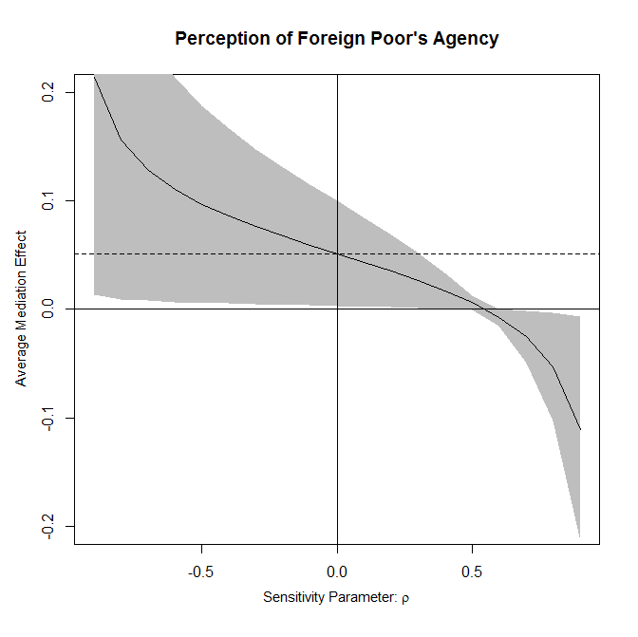*

(Sensitivity analysis of mediation model 1 in Table 2. *Mi*=Perception of Foreign Poor’s Agency)

**AG experiment**

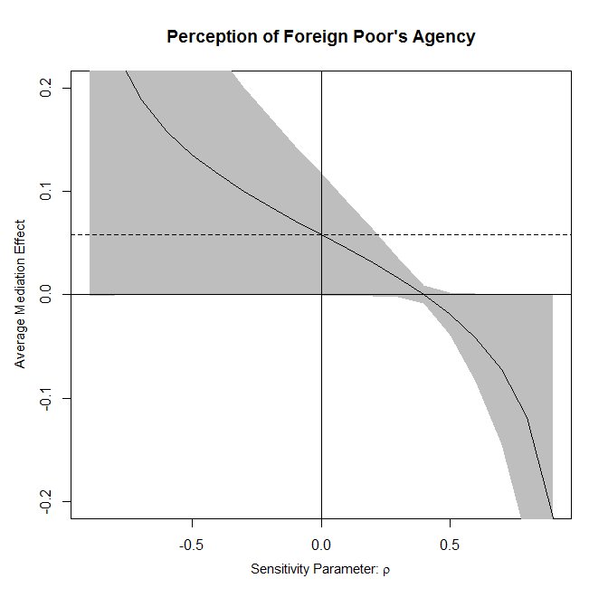

(Sensitivity analysis of mediation model 1 in Table 3. *Mi*=Perception of Foreign Poor’s Agency)